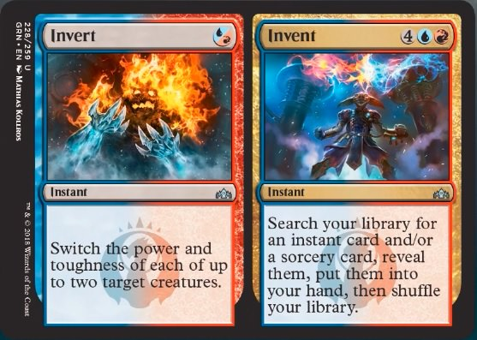

*From Guilds of Ravnica Release Notes:*

Invert has received the following errata:  
*“Switch the power and toughness of each of up to two target creatures until end of turn.”*

If you chose two targets, Invert switches the power and toughness of one creature and it switches the power and toughness of another creature. It doesn't switch one creature's power with another creature's power.

Effects that switch a creature's power and toughness apply after all other effects, regardless of when those effects began to apply. For instance, if you cast Invert targeting a 1/2 creature then give it +2/+0 later in the turn, it's a 2/3 creature, not a 4/1 creature.